The Study of Calculus

Calculus is the fascinating study of the mathematics of change. This semester will be broken down into two main categories.
- Differential calculus (concerning slopes of curves and rates of change)
- Integral calculus (concerning the accumulation of various quantities and areas under curves)
It is instructive to begin with some example problems that fall into these categories.

Example 1: Consider two locations: Island A (near the north pole) and Island B (near the equator). Suppose that Island A is always F and Island B is always F. Suppose that Alice is on Island A and Bob is on Island B. Suppose that at 12:00 pm Alice takes a trip to Island B, and Bob takes a trip to Island A. Suppose that Alice arrives at Island B at 9:00 pm, and Bob arrives at Island A at 9:00 pm (assume there are no time zones for this problem and assume you know nothing about the route that Alice/Bob took). Must there have been a point in time in Alice’s and Bob’s trip when Alice and Bob were experiencing the exact same temperature?

Note: The above example is a differential calculus problem, and we will be able to prove whether the answer is yes or no by the end of chapter 2.

Example 2: The function is very important in the study of statistics. In fact, it is the basis for the student’s T-distribution. Therefore, it is important for the statistician to be able to answer questions like: What is the exact area under this curve as x varies from 1 to -1? A picture is below.
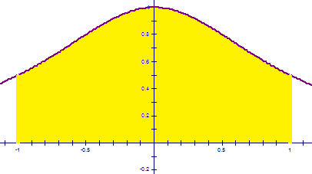

Note: This example is an integral calculus problem, and we will be able to solve it by the end of chapter 5.


Example 3: Suppose a hole has been punctured in the side of a barrel which contains some liquid. Suppose the liquid drains from the tank at a rate defined by a function . How much liquid will leak out of the tank within the first 30 minutes?

Note: This is another example of an integral calculus problem.

2.2 Limits (An Intuitive Approach)
Definition (Intuitive): Suppose is defined when x is near the number a. (This means that f is defined on some open interval that contains a, except possibly at a itself.) Then we write:

and say “the limit of , as x approaches a, equals L”

if we can make the values of (i.e., the y-values) “arbitrarily” close to L by taking x to be sufficiently close to a.

Short for “limit”
The function we are taking the limit of.
Variable
What our variable is approaching
Notation:

Example 4: What do we expect the value of to be?

We can look at the graph and a table of values to see what this might be equal to.
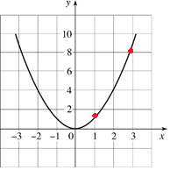

Table:
x | 1 | 1.5 | 1.9 | 1.99 | 1.999 | 2 | 2.001 | 2.01 | 2.1 | 2.5 | 3
 | 1 | 2.25 | 3.61 | 3.9601 | 3.996001 | ??? | 4.004001 | 4.0401 | 4.41 | 6.25 | 9

Based on these results we might say that .

Example 5:
Use the following graph to find the following values.
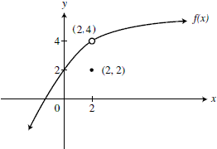
- What the function is

- What the function is approaching

NOTE: When finding limits we are interested in what the function is approaching not what it is equal to at the value of a.

One Sided Limits

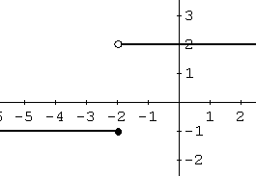
General Idea:
Consider the following function :

Find .

This question is difficult to answer. The graph seems to approach two different values as (depending on which direction/side we approach from).

Definition (Intuitive):
- We write

and say the limit of as x approaches a from the left is equal to L if we can make the values of
arbitrarily close to L by taking x to be sufficiently close to a and x less than a.

- Similarly we write

and say the limit of as x approaches a from the right is equal to L if we can make the values of
arbitrarily close to L by taking x to be sufficiently close to a and x greater than a.

Example 6:

Consider the following function :
Find the following:

- does not exist (DNE)

NOTE: If a limit does not approach any one real number then we say that the limit “does not exist”.
DNE is short for “Does not exist”, and is a common abbreviation used in calculus.

This leads us to the following theorem

Theorem: Suppose that f is a function whose domain contains an open interval containing a with a possibly removed. Then, if and only if and .

Note: This theorem provides us with a way to prove that limits do not exist. In particular, if , we may conclude DNE.

Example 7:
Compute each of the following values for the graph of depicted to the right.
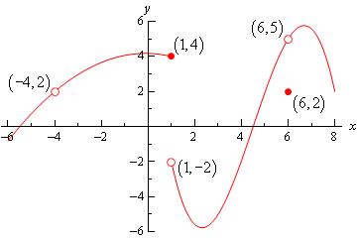
- is undefined

- DNE (Limits from the left & right are different)

- (Limits from the left & right are both 5).

Infinite Limits
Exploration: Suppose that we are interested in finding .
Recall that is the number y such that . This means that , , , etc.

So, as we get close to zero on the right hand side, the natural log function appears to be getting arbitrarily small. Moreover, since we will not regard infinity as a number in this class, the natural log function is not approaching any single number as we approach zero from the right hand side.

So, we have that DNE. However, we would still like to have notation that indicates this type of behavior. So, we write: .

Note: It is very important to understand that when we write we are not saying that the limit exists. We are simply giving more detail as to exactly how the limit DNE.

Note: Natural log has a vertical asymptote of x=0, we expect to see infinite limits near vertical asymptotes.

Note: In higher level mathematics courses, it is possible to regard infinity as a number. When we do this, we say we are working in the extended real number system. Throughout this class we will never regard infinity as a number. Rather, we will use it to express the idea of arbitrarily large/small. This is what your textbook does as well.

Definition (Intuitive): If f increases without bound as x approaches a from both sides then we say

(Note the limit here does not exists)

Question: How would one need to change the intuitive definition above in order to give an intuitive definition of ?

Note: As we saw in the exploration, we can use the infinite limit idea for one sided limits as well.
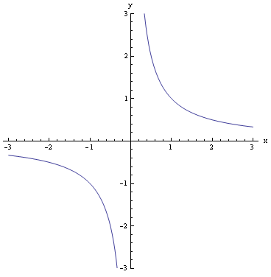
Example 8: Find each of the following limits.

- Since we can say DNE.

